Screenly

I have set up a large monitor in the common area at 2nd floor at Sentralen (Provided by Sentralen).

The display is controlled by a program called Screenly and is running on a small Raspberry Pi processor (this year a Raspberry Pi 3a lend from RA).

Enough on the technical stuff…

The content on the screen is controlled by accessing this URL:

http://10.55.88.152 from a computer/pad connected on the WiFi network Sentralen1x
(User/Pwd: admin/oslo2007jazz).

The program is capable of displaying graphical images (preferable in a resolution of 1920x1080) and Web-pages.
Each item is “assigned” a period to be shown (from/to date and time) and also the number of seconds to be displayed.
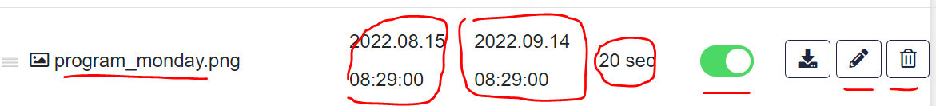
Quick instructions:
- The “tripple”-icon on the left is used to move a item up/down in the list
- The green switch is used to select if the item is active or passive (not shown)
- The pencil-icon is selected in order to edit the date-span and/or display-length
- and finally the garbage-icon is used to remove the item from the list

If you enter a URL for a streaming site the program will calculate the display-length (that may be overridden…)

New items on the list are added using the”Add Asset”-button on the top right. You may then drag/drop a graphics file or enter a URL.

Note: I hope to get hold of a more powerful Raspberry Pi by tomorrow, but for now….

2022-08-15/ralm

More stuff on the HW/SW
The Screenly SW is installed like this:
- Install a Buster-image to a fresh SD-card (the non-Desktop version)
- Install and boot the RPi
- Perform a update/upgrade
- Install Screenly (as user pi) by executing this command:
- bash <(curl -sL https://www.screenly.io/install-ose.sh)
- Note: Do NOT install the Network Control part!

